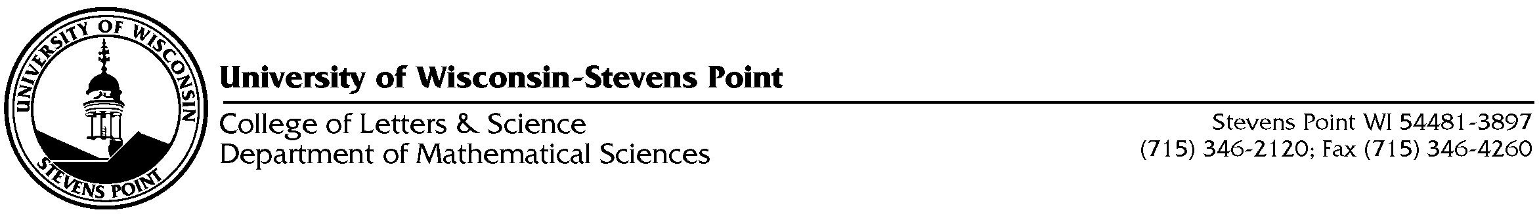March 8, 2012

Dear MAPPS Supporter:
I am writing to ask you for your support of the upcoming Math and Parent Partners Program presented by the University of Wisconsin-Stevens Point and the YMCA. The Math and Parent Partners (MAPPS) Program engages parents of K-8 children in the mathematics of the schools. The Program empowers parents with new mathematical knowledge and with new self-confidence about learning mathematics, creates families that learn mathematics together, improves children's competencies in mathematics, and gets the broader community embracing mathematics as something everybody can do and enjoy.
UW-Stevens Point and the YMCA are excited to offer this program to our community. In addition to offering the math sessions free of charge, we are also providing babysitting services and refreshments to our participants. I am asking that you to help us by providing breakfast items for the participants at one of our sessions. We are also seeking door prizes. The program dates are Saturdays March 28-May 16. We expect approximately 100 participants per session. As I hope you are able to help us, we will have a closer number of participants on March 25 and will be able to provide this final number to you. We plan to purchase items such as donuts and fruit, but the choice of venue would be yours.
Thank you for your willingness to help us. Your generosity will go a long way.

Sincerely,
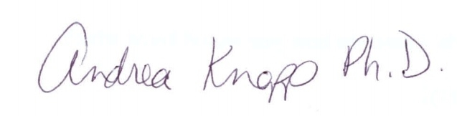

Andrea Knapp, Ph.D.
Associate Professor
Mathematical Sciences
University of Wisconsin-Stevens Point
Director, Central Wisconsin MAPPS

