https://www.instagram.com/p/B8uKwiWHl_9/
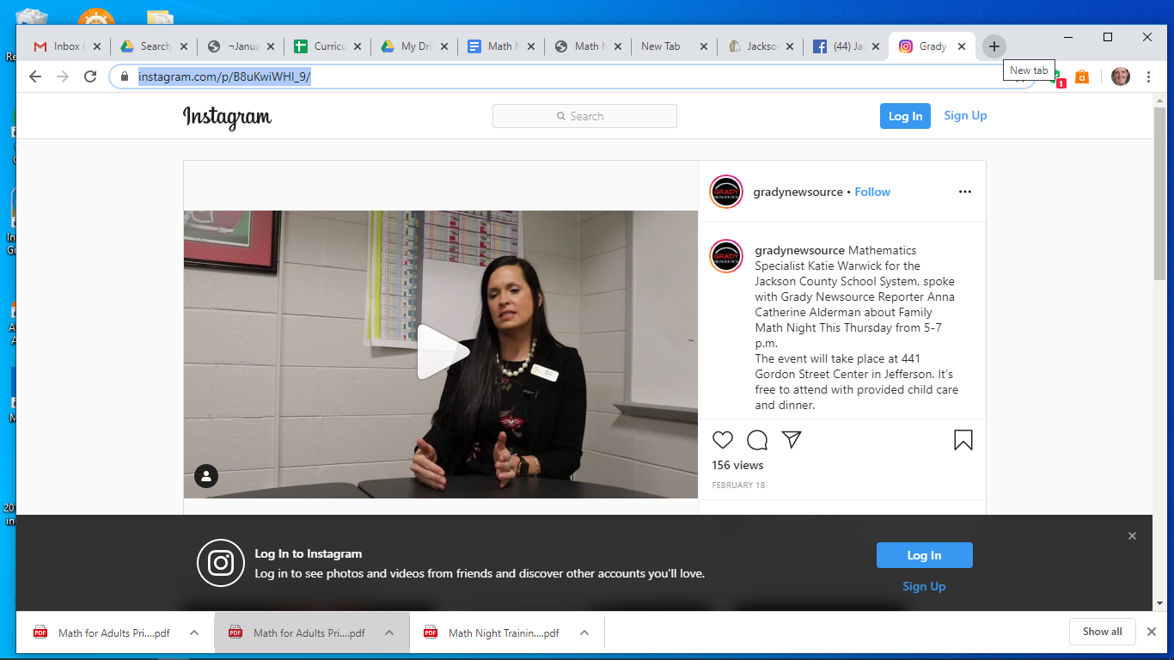

https://www.youtube.com/watch?v=WVx7A1y8L80&feature=youtu.be (See 14:48-16:49)

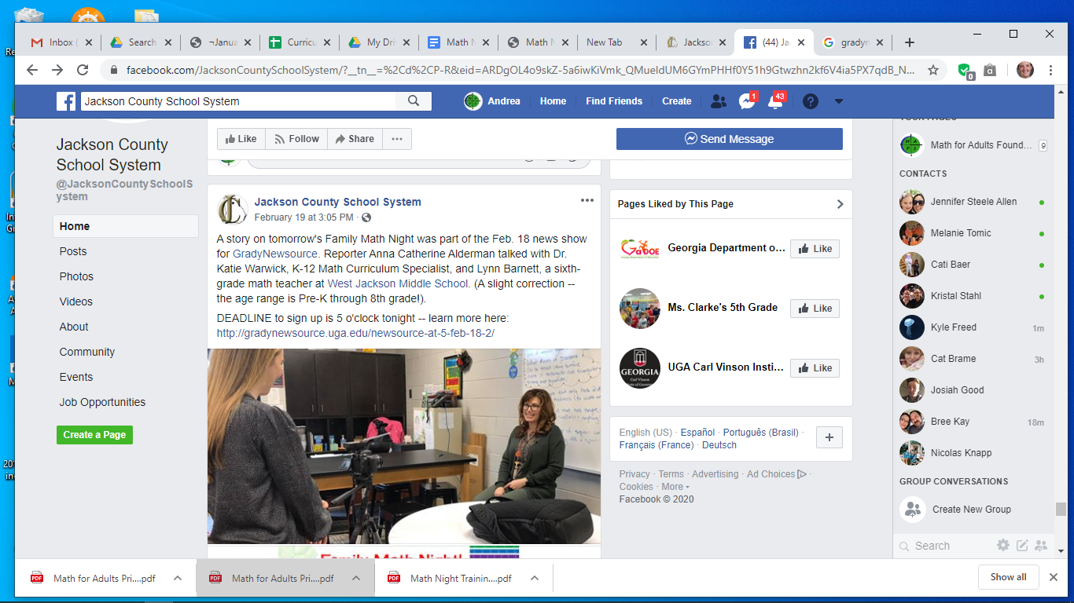
https://www.youtube.com/watch?v=WVx7A1y8L80&feature=youtu.be (See 14:48-16:49)

